Tool #4: How to Label

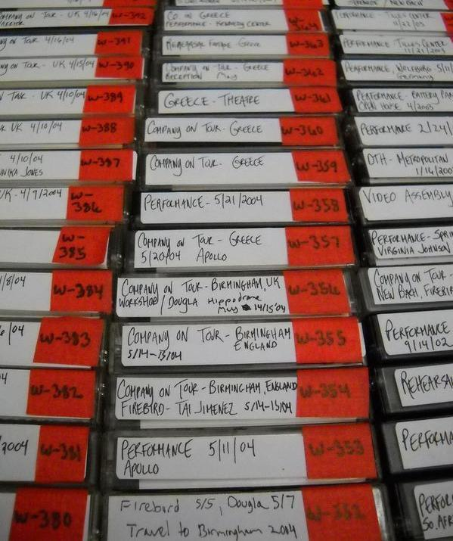  Image of Dance Theatre of Harlem archive project: MiniDVs with given new labels and unique numbers for easier inventorying. | - Write softly on the back of a photograph with a no. 2 pencil.  - Refrain from using stick-on labels directly on an item (on container is fine), as they can damage media and photographic prints.  - Labels on audiovisual material could cause the item to get stuck in a machine, including CD and DVD labels.  - Write directly on an item or use labels in designated label areas on media (i.e. VHS tapes have indented areas on bottom and front where labels can be safely applied).

On the next page are some suggestions as to what information should be on labels for different items.

Box Label  Dance Title Content  Type/Format  Dates  Box # | Audio Tape Label  Title  Dates  Unique #
Video Tape Label  Name of choreographic work, Date  Performance location  Names of performers  Photographer/videographer | Folder Label  Description of folder contents  Dates  Folder # (out of total)

